Supplementary Data
Spatiotemporal genetic change among Canadian wood bison (Bison bison athabascae) Populations
Alexander P. Depew^{1*}, Gregory A. Wilson², Christopher J. Kyle³, Christina M. McCosker³, Christopher J. Lewis⁴, Mark C. Ball⁵

¹ Environmental & Life Sciences Program Graduate Program, Trent University, Ontario, Canada
² Parks Canada Agency, Elk Island National Park, Fort Saskatchewan, Alberta, Canada
³ Forensic Science Department, Trent University, Peterborough, Ontario, Canada
⁴ Ministry of Water, Land and Resource Stewardship (Northeast Region), Government of British Columbia, Port Alberni, British Columbia, Canada
⁵ Fish & Wildlife Stewardship, Environment and Protected Areas, Government of Alberta, Edmonton, Alberta, Canada
*Corresponding Author: adepew004@gmail.com

Supplementary Data SD1. Historic distribution of wood (B. b. athabascae) and plains bison (B. b. bison). Ranges representative of pre-settlement distributions of (1) wood bison, and (2) plains bison. Modified from Gates et al. 2010.
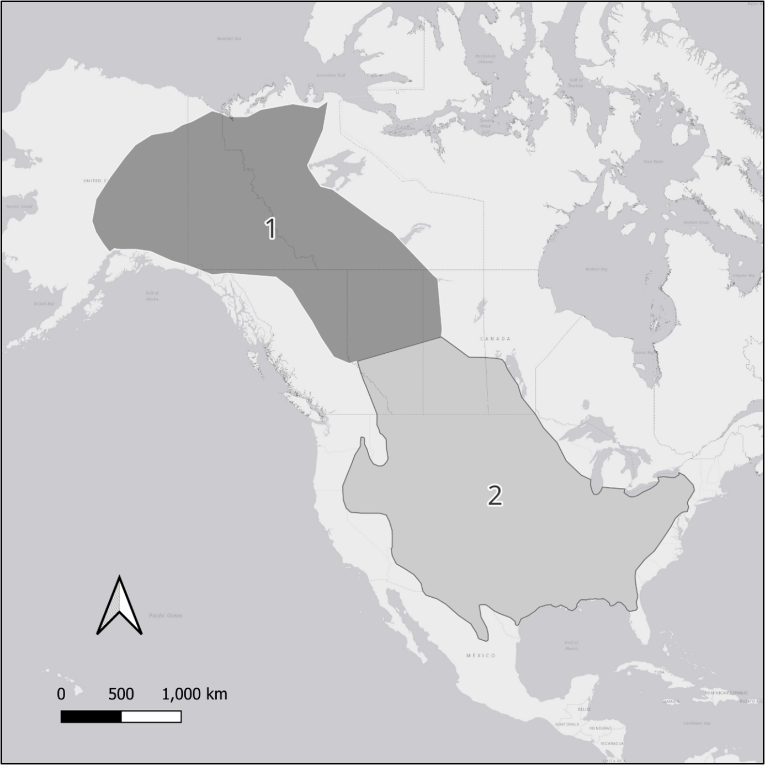

Supplementary Data SD2. Summary of 50 autosomal microsatellite loci used in this study, including number of observed alleles (N_{A}), polymorphic information content (PIC), and number of samples successfully genotyped (N) at each locus.
Locus | Chromosomeª | N_{A} | PIC | N
BMS1117 | 21 | 4 | 0.469 | 881
TGLA53 | 16 | 6 | 0.634 | 876
BMC4214 | 3 | 6 | 0.697 | 881
BM1225 | 20 | 14 | 0.626 | 880
BM47 | 23 | 6 | 0.167 | 875
BMS1315 | 5 | 6 | 0.659 | 880
IL4 | 7 | 10 | 0.746 | 874
BM2113 | 2 | 10 | 0.558 | 881
BMS1716 | 11 | 5 | 0.561 | 881
BM1706 | 16 | 8 | 0.555 | 879
BMS1675 | 27 | 5 | 0.423 | 881
BMS1857 | 29 | 15 | 0.764 | 879
BMS1001 | 27 | 5 | 0.552 | 881
BMS601 | 19 | 7 | 0.664 | 865
BM720 | 13 | 10 | 0.663 | 875
ILSTS102 | 25 | 5 | 0.187 | 878
BMS1074 | 4 | 5 | 0.598 | 880
BMS1172 | 4 | 5 | 0.450 | 881
BMS2258 | 7 | 7 | 0.773 | 881
BM757 | 9 | 8 | 0.573 | 880
SPS115 | 15 | 6 | 0.495 | 877
BMS527 | 1 | 10 | 0.749 | 880
BM2830 | 5 | 11 | 0.694 | 877
INRA194 | 22 | 7 | 0.634 | 876
BMS941 | 17 | 4 | 0.544 | 878
INRA037 | 10 | 6 | 0.542 | 878
BM4107 | 20 | 7 | 0.688 | 880
TGLA122 | 21 | 4 | 0.505 | 880
HUJ246 | 3 | 6 | 0.441 | 877
BMS528 | 10 | 7 | 0.607 | 879
BM4440 | 2 | 6 | 0.632 | 880
TGLA44 | 2 | 6 | 0.574 | 880
BMS510 | 28 | 5 | 0.600 | 877
BMS1355 | 18 | 5 | 0.463 | 881
BM1824 | 1 | 7 | 0.655 | 881
BMS812 | 15 | 7 | 0.696 | 881
BMS2639 | 18 | 9 | 0.752 | 881
BMS410 | 12 | 6 | 0.544 | 881
AGLA232 | 13 | 10 | 0.653 | 881
BM17132 | 19 | 8 | 0.690 | 878
BM4028 | 12 | 6 | 0.521 | 603
BM711 | 8 | 5 | 0.268 | 878
INRA133 | 6 | 8 | 0.653 | 878
RM372 | 8 | 10 | 0.632 | 880
BM4311 | 6 | 8 | 0.713 | 875
BMS1747 | 14 | 7 | 0.680 | 874
BL1036 | 14 | 8 | 0.475 | 880
BM1862 | 17 | 6 | 0.654 | 875
BMS1862 | 24 | 10 | 0.804 | 876
URB011 | 29 | 7 | 0.712 | 833
ªChromosomal locations as reported in the animal genome cattle database (animalgenome.org)
Supplementary Data SD6. Summary of significant linkage disequilibrium. Significant pairs of loci identified following Benjamini-Hochberg p-value correction between pairs of genetic loci within each temporal group. Herd abbreviations are as described in Table 1.
Cohort | Herd | Locus 1 | Chrª | Locus 2 | Chrª | p-value | Std Error | MCMC Switches | Adjusted p-value
T1 | EINPW | BMS1315 | 5 | TGLA44 | 2 | <0.001 | <0.001 | 49354 | 0.042336
T1 | HZ | BM711 | 8 | INRA194 | 22 | <0.001 | <0.001 | 41971 | <0.001
T1 | HZ | RM372 | 8 | URB011 | 29 | <0.001 | <0.001 | 19488 | <0.001
T2 | EINPP | BM1824 | 1 | INRA037 | 10 | <0.001 | <0.001 | 62199 | 0.048216
T2 | EINPP | BM757 | 9 | SPS115 | 15 | <0.001 | <0.001 | 18937 | <0.001
T2 | WBNPGR | BMS1001 | 27 | IL4 | 7 | <0.001 | <0.001 | 24169 | <0.001
T2 | WBNPHC | BMS1857 | 29 | IL4 | 7 | <0.001 | <0.001 | 5006 | <0.001
T2 | WBNPNY | AGLA232 | 13 | BMS1315 | 5 | <0.001 | <0.001 | 27811 | <0.001
T2 | WBNPPAD | BM1225 | 20 | BMS410 | 12 | <0.001 | <0.001 | 17045 | <0.001
T2 | WBNPPAD | BMS410 | 12 | BMS812 | 15 | <0.001 | <0.001 | 25452 | 0.01568
T2 | WBNPPAD | BM1225 | 20 | IL4 | 7 | <0.001 | <0.001 | 8598 | <0.001
ªChromosomal locations as reported in the animal genome cattle database (animalgenome.org)

Supplementary Data SD9. 1986 – 2015 cohort genetic difference (Weir’s F_{ST}) between populations using the Including Null Alleles (INA) and Excluding Null Alleles (ENA) correction method as implemented in the FreeNA software. INA results are reported below the diagonal and ENA above. Locus BM4028 was excluded prior to autosomal null allele estimation due to a high proportion of missing data across samples.
Herd | EINPP | EINPW | ETH | HZ | MBS | NORD | RL | WAB | WBNPGR | WBNPHC | WBNPLB | WBNPNY | WBNPPAD | WENT
EINPP |  | 0.162 | 0.161 | 0.159 | 0.122 | 0.164 | 0.143 | 0.141 | 0.092 | 0.102 | 0.109 | 0.130 | 0.076 | 0.119
EINPW | 0.165 |  | 0.027 | 0.023 | 0.059 | 0.030 | 0.107 | 0.204 | 0.051 | 0.036 | 0.045 | 0.043 | 0.048 | 0.052
ETH | 0.163 | 0.027 |  | 0.048 | 0.062 | 0.044 | 0.125 | 0.213 | 0.058 | 0.047 | 0.059 | 0.050 | 0.051 | 0.073
HZ | 0.164 | 0.023 | 0.047 |  | 0.067 | 0.044 | 0.116 | 0.197 | 0.062 | 0.049 | 0.059 | 0.047 | 0.055 | 0.057
MBS | 0.123 | 0.059 | 0.062 | 0.068 |  | 0.075 | 0.096 | 0.162 | 0.031 | 0.025 | 0.022 | 0.039 | 0.027 | 0.063
NORD | 0.167 | 0.030 | 0.043 | 0.043 | 0.076 |  | 0.130 | 0.206 | 0.058 | 0.050 | 0.058 | 0.052 | 0.055 | 0.068
RL | 0.146 | 0.109 | 0.126 | 0.119 | 0.099 | 0.131 |  | 0.197 | 0.079 | 0.079 | 0.100 | 0.091 | 0.079 | 0.072
WAB | 0.145 | 0.207 | 0.213 | 0.200 | 0.165 | 0.207 | 0.200 |  | 0.165 | 0.158 | 0.170 | 0.172 | 0.130 | 0.189
WBNPGR | 0.094 | 0.051 | 0.057 | 0.062 | 0.030 | 0.057 | 0.080 | 0.166 |  | -0.001 | 0.005 | 0.011 | -0.001 | 0.023
WBNPHC | 0.104 | 0.037 | 0.046 | 0.049 | 0.025 | 0.048 | 0.080 | 0.159 | -0.003 |  | 0.009 | 0.011 | 0.002 | 0.018
WBNPLB | 0.111 | 0.046 | 0.059 | 0.061 | 0.023 | 0.055 | 0.102 | 0.171 | 0.004 | 0.009 |  | 0.018 | 0.009 | 0.033
WBNPNY | 0.132 | 0.044 | 0.050 | 0.046 | 0.040 | 0.051 | 0.091 | 0.175 | 0.010 | 0.011 | 0.018 |  | 0.016 | 0.027
WBNPPAD | 0.076 | 0.049 | 0.052 | 0.056 | 0.027 | 0.056 | 0.081 | 0.132 | -0.001 | 0.002 | 0.009 | 0.015 |  | 0.027
WENT | 0.126 | 0.053 | 0.073 | 0.058 | 0.065 | 0.068 | 0.076 | 0.196 | 0.023 | 0.017 | 0.029 | 0.028 | 0.028

Herd | AISH | CL | EINPP | EINPW | ETH | HZ | MBS | NAH | NORD | RL | WAB | WBNPGR | WBNPHC | WBNPLB | WBNPNY | WBNPPAD | WENT
AISH |  | 0.055 | 0.192 | 0.015 | 0.037 | 0.031 | 0.062 | 0.053 | 0.045 | 0.120 | 0.217 | 0.048 | 0.043 | 0.048 | 0.071 | 0.045 | 0.061
CL | 0.056 |  | 0.222 | 0.059 | 0.075 | 0.074 | 0.102 | 0.113 | 0.088 | 0.141 | 0.269 | 0.085 | 0.076 | 0.081 | 0.091 | 0.084 | 0.107
EINPP | 0.194 | 0.224 |  | 0.169 | 0.185 | 0.187 | 0.141 | 0.135 | 0.203 | 0.162 | 0.149 | 0.113 | 0.123 | 0.136 | 0.142 | 0.103 | 0.144
EINPW | 0.015 | 0.058 | 0.172 |  | 0.028 | 0.030 | 0.061 | 0.043 | 0.039 | 0.122 | 0.215 | 0.038 | 0.038 | 0.042 | 0.061 | 0.034 | 0.057
ETH | 0.038 | 0.077 | 0.187 | 0.028 |  | 0.050 | 0.073 | 0.063 | 0.062 | 0.130 | 0.208 | 0.048 | 0.051 | 0.061 | 0.075 | 0.054 | 0.078
HZ | 0.031 | 0.075 | 0.190 | 0.030 | 0.051 |  | 0.082 | 0.070 | 0.078 | 0.133 | 0.207 | 0.055 | 0.052 | 0.054 | 0.073 | 0.053 | 0.076
MBS | 0.064 | 0.103 | 0.143 | 0.062 | 0.074 | 0.083 |  | 0.066 | 0.083 | 0.089 | 0.161 | 0.023 | 0.031 | 0.036 | 0.040 | 0.033 | 0.058
NAG | 0.052 | 0.111 | 0.140 | 0.041 | 0.063 | 0.071 | 0.067 |  | 0.076 | 0.124 | 0.183 | 0.046 | 0.038 | 0.049 | 0.065 | 0.035 | 0.075
NORD | 0.046 | 0.089 | 0.208 | 0.039 | 0.063 | 0.079 | 0.086 | 0.077 |  | 0.143 | 0.216 | 0.069 | 0.056 | 0.065 | 0.083 | 0.061 | 0.085
RL | 0.122 | 0.143 | 0.163 | 0.124 | 0.133 | 0.136 | 0.091 | 0.126 | 0.147 |  | 0.203 | 0.084 | 0.082 | 0.090 | 0.097 | 0.083 | 0.111
WAB | 0.220 | 0.272 | 0.152 | 0.218 | 0.211 | 0.210 | 0.163 | 0.189 | 0.220 | 0.207 |  | 0.150 | 0.154 | 0.171 | 0.182 | 0.137 | 0.217
WBNPGR | 0.048 | 0.086 | 0.114 | 0.038 | 0.049 | 0.056 | 0.023 | 0.048 | 0.071 | 0.086 | 0.152 |  | 0.003 | 0.012 | 0.019 | 0.002 | 0.019
WBNPHC | 0.044 | 0.077 | 0.125 | 0.039 | 0.052 | 0.053 | 0.031 | 0.041 | 0.058 | 0.084 | 0.156 | 0.003 |  | 0.002 | 0.009 | 0.004 | 0.028
WBNPLB | 0.047 | 0.081 | 0.138 | 0.043 | 0.061 | 0.054 | 0.036 | 0.051 | 0.066 | 0.091 | 0.173 | 0.011 | 0.001 |  | 0.005 | 0.012 | 0.035
WBNPNY | 0.071 | 0.090 | 0.145 | 0.061 | 0.075 | 0.074 | 0.038 | 0.066 | 0.084 | 0.098 | 0.184 | 0.018 | 0.008 | 0.004 |  | 0.022 | 0.054
WBNPPAD | 0.044 | 0.084 | 0.106 | 0.034 | 0.054 | 0.053 | 0.033 | 0.036 | 0.062 | 0.083 | 0.139 | 0.002 | 0.003 | 0.012 | 0.021 |  | 0.022
WENT | 0.062 | 0.108 | 0.145 | 0.055 | 0.078 | 0.075 | 0.056 | 0.069 | 0.085 | 0.112 | 0.217 | 0.015 | 0.028 | 0.036 | 0.054 | 0.022
Supplementary Data SD10. 2016 – 2025 cohort genetic difference (Weir’s F_{ST}) between populations using the Including Null Alleles (INA) and Excluding Null Alleles (ENA) correction method as implemented in the FreeNA software. INA results are reported below the diagonal and ENA above. Locus BM4028 was excluded prior to autosomal null allele estimation due to a high proportion of missing data across samples.

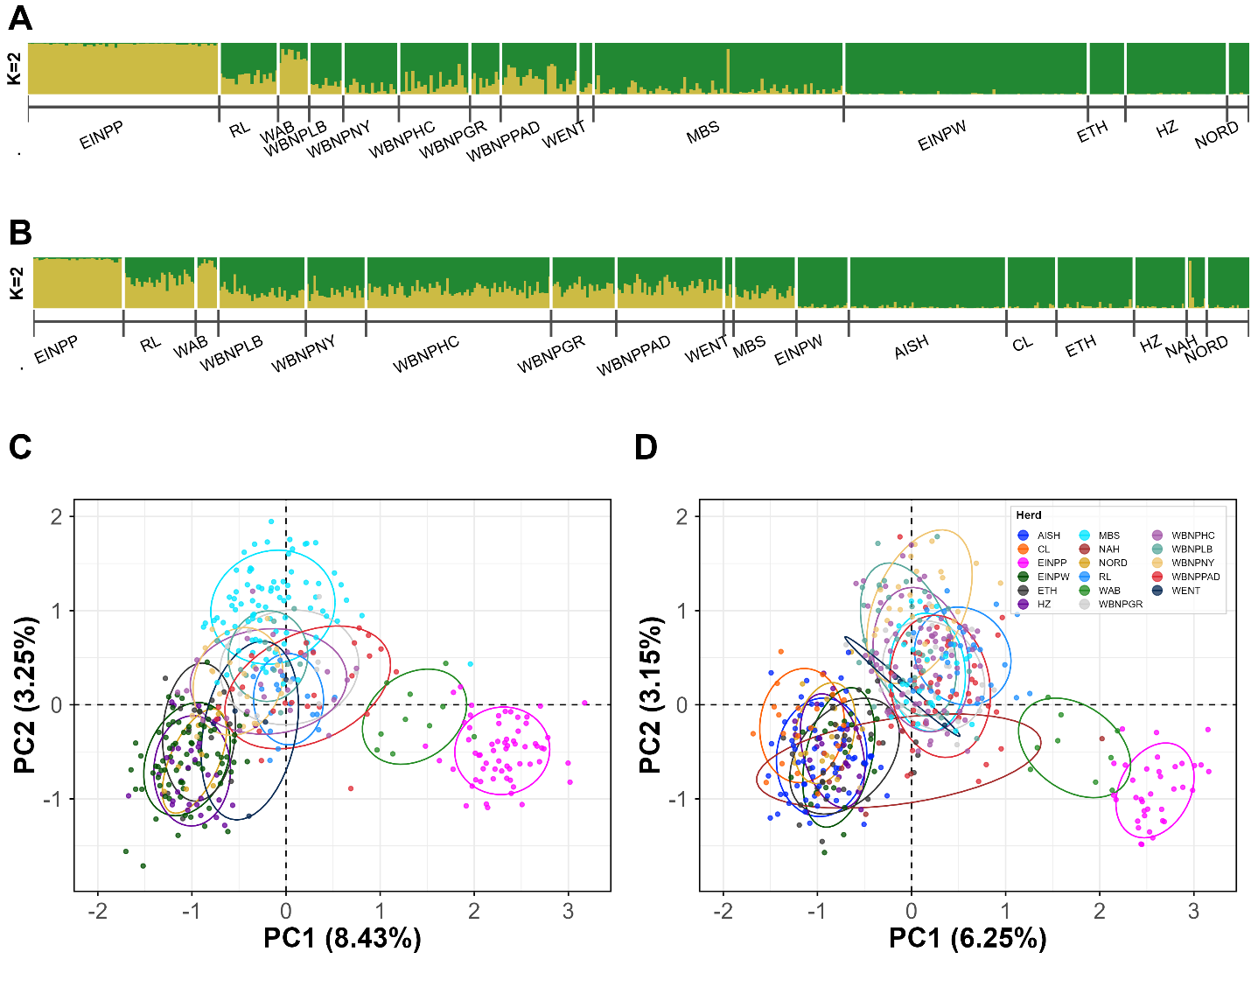

Supplementary Data SD13. Population structure and Genetic Clustering of Canadian wood (Bison bison athabascae) and Plains Bison (B. b. bison) herds. Bayesian clustering results from STRUCTURE based on 47 nuclear microsatellite loci for samples collected (A) 1986 – 2015 and (B) 2016 – 2025 at K = 2, depicting relative admixture between wood and plains bison in each herd. Principal Component Analysis (PCA) evaluating global genetic structuring and population differentiation, including plains bison samples collected (C) 1986 – 2015 and (D) 2016 – 2025. PCA ellipses represent one standard deviation around the centroid for each cluster, and percentage values indicate proportion of genetic variance explained by principal components. Herd abbreviations are as described in Table 1.

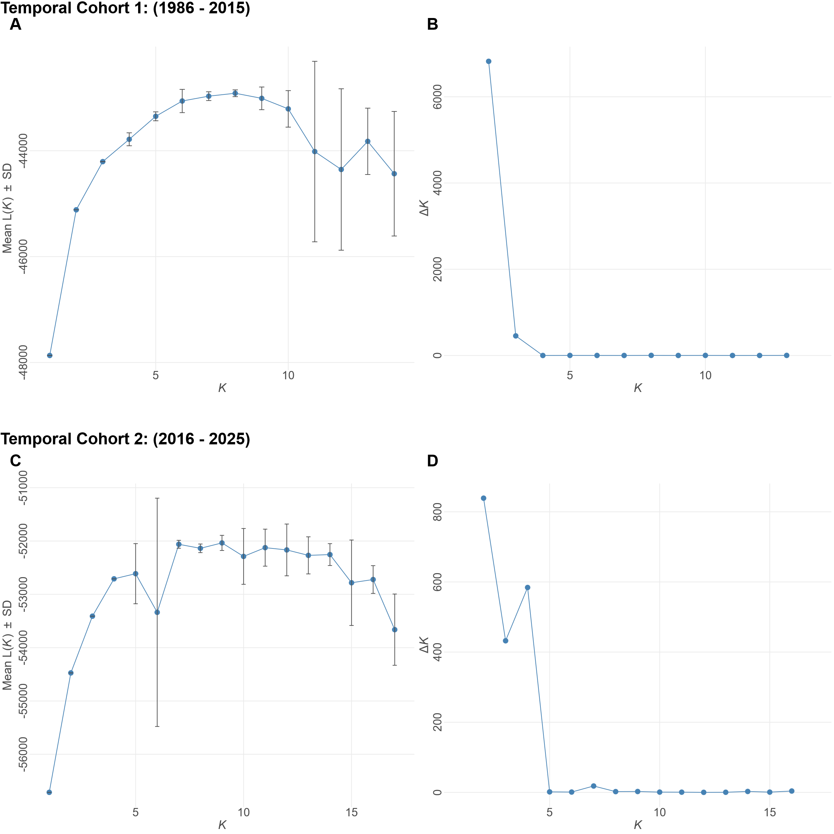
Supplementary Data SD14. STRUCTURE diagnostic plots for Wood Bison (B. b. athabascae) and Plains Bison (B. b. bison) herd samples collected between 1986 – 2015 (top) and 2016 – 2025 (bottom). (A, C) Mean Log-likelihood (L(K)) over 10 replicates of K. (B, D) Delta K (ΔK) calculated following Evanno method (Evanno et al., 2005).

Supplementary Data SD15. Mean cluster assignment coefficients (Q) between wood (B. b. athabascae) and plains bison (B. b. bison) for global temporal datasets. Posterior probability of assignment for sampled individuals within each identified herd at inferred K = 2 clusters, representing subspecific assignment between wood and plains bison, using Bayesian clustering approach as implemented by STRUCTURE. T1 = temporal group 1 (1986 - 2015) and T2 = temporal group 2 (2016 - 2025). Mean values for each population are reported with the standard deviation. Herd abbreviations are as described in Table 1.
 | Herd | Q_{Wood} | Q_{Plains}
T1 | EINPP | 0.023 ± 0.017 | 0.977 ± 0.017
T1 | EINPW | 0.983 ± 0.017 | 0.017 ± 0.017
T1 | ETH | 0.986 ± 0.005 | 0.014 ± 0.005
T1 | HZ | 0.985 ± 0.010 | 0.015 ± 0.010
T1 | MBS | 0.898 ± 0.120 | 0.102 ± 0.120
T1 | NORD | 0.980 ± 0.014 | 0.020 ± 0.014
T1 | RL | 0.652 ± 0.084 | 0.348 ± 0.084
T1 | WAB | 0.244 ± 0.102 | 0.756 ± 0.102
T1 | WBNPGR | 0.736 ± 0.130 | 0.264 ± 0.130
T1 | WBNPHC | 0.781 ± 0.160 | 0.219 ± 0.160
T1 | WBNPLB | 0.789 ± 0.055 | 0.211 ± 0.055
T1 | WBNPNY | 0.875 ± 0.095 | 0.125 ± 0.095
T1 | WBNPPAD | 0.660 ± 0.164 | 0.340 ± 0.164
T1 | WENT | 0.859 ± 0.077 | 0.141 ± 0.077
T2 | AISH | 0.960 ± 0.027 | 0.040 ± 0.027
T2 | CL | 0.957 ± 0.034 | 0.043 ± 0.034
T2 | EINPP | 0.033 ± 0.018 | 0.967 ± 0.018
T2 | EINPW | 0.944 ± 0.029 | 0.056 ± 0.029
T2 | ETH | 0.946 ± 0.043 | 0.054 ± 0.043
T2 | HZ | 0.958 ± 0.025 | 0.042 ± 0.025
T2 | MBS | 0.676 ± 0.086 | 0.324 ± 0.086
T2 | NAH | 0.797 ± 0.307 | 0.203 ± 0.307
T2 | NORD | 0.958 ± 0.025 | 0.042 ± 0.025
T2 | RL | 0.429 ± 0.103 | 0.571 ± 0.103
T2 | WAB | 0.129 ± 0.070 | 0.871 ± 0.070
T2 | WBNPGR | 0.571 ± 0.092 | 0.429 ± 0.092
T2 | WBNPHC | 0.618 ± 0.100 | 0.382 ± 0.100
T2 | WBNPLB | 0.676 ± 0.105 | 0.324 ± 0.105
T2 | WBNPNY | 0.665 ± 0.110 | 0.335 ± 0.110
T2 | WBNPPAD | 0.556 ± 0.109 | 0.444 ± 0.109
T2 | WENT | 0.682 ± 0.111 | 0.318 ± 0.111

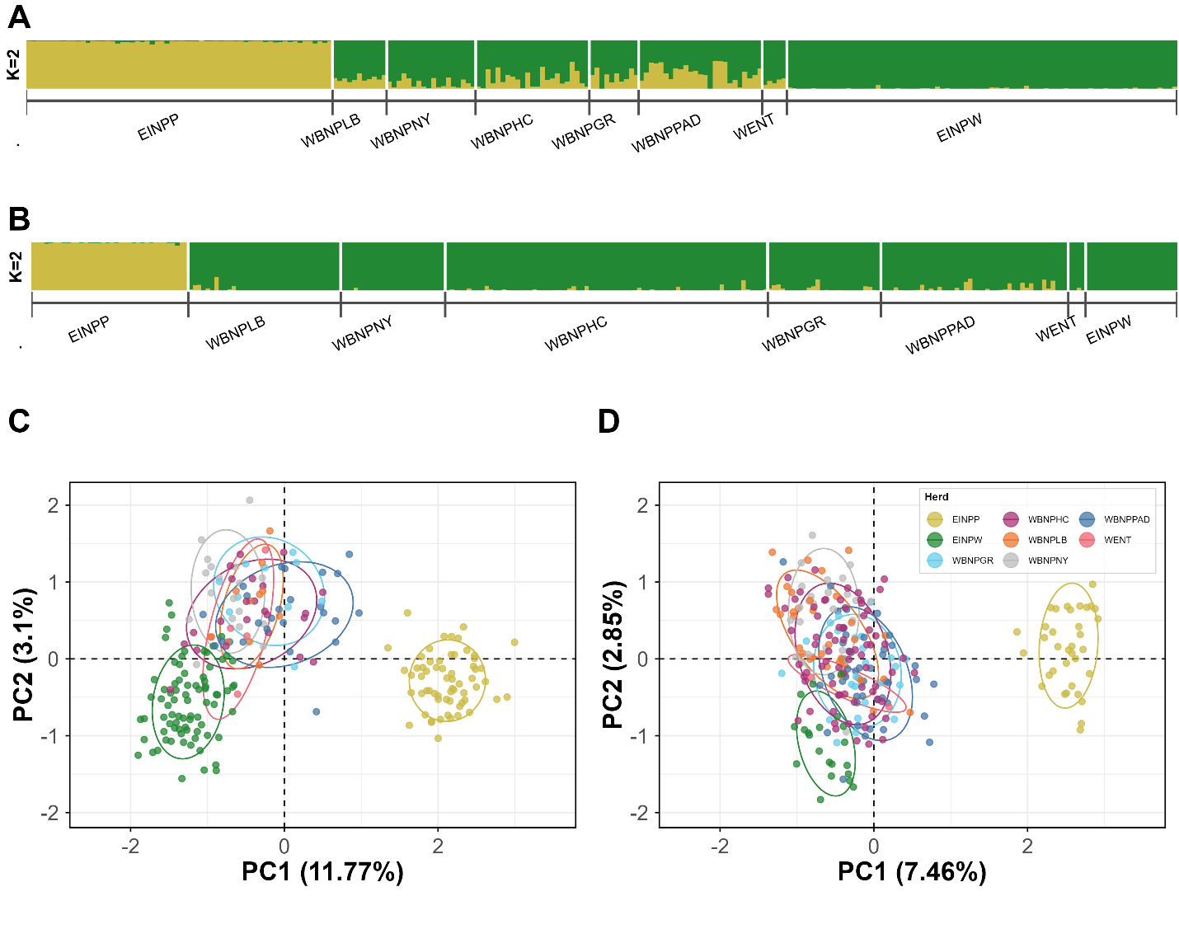
Supplementary Data SD16. Population Structure and Genetic Clustering of Wood Buffalo National Park (WBNP) Wood Bison (B. b. athabascae) Compared to Elk Island National Park (EINP) Wood and Plains (B. b. bison) Bison herds. Bayesian clustering results from STRUCTURE based on 47 nuclear microsatellite loci for samples collected (A) 1986 - 2015 and (B) 2016 - 2025 at K = 2, depicting relative admixture between wood and plains bison in each herd. Principal Component Analysis (PCA) evaluating global genetic structuring and population differentiation, including plains bison samples collected (C) 1986 - 2015 and (D) 2016 - 2025. PCA ellipses represent one standard deviation around the centroid for each cluster, and percentage values indicate proportion of genetic variance explained by principal components. Herd abbreviations are as described in Table 1.

Supplementary Data SD17. Mean cluster assignment coefficients (Q) between wood and plains bison for Wood Buffalo National Park temporal datasets. Posterior probability of assignment for sampled individuals within each identified herd at inferred K = 2 clusters, representing subspecific assignment between wood (B. b. athabascae) and plains (B. b. bison) bison, using Bayesian clustering approach as implemented by STRUCTURE. T1 = temporal group 1 (1986 – 2015) and T2 = temporal group 2 (2016 – 2025). Mean values for each population are reported with the standard deviation. Herd abbreviations are as described in Table 1.
 | Herd | Q_{Wood} | Q_{Plains}
T1 | GR | 0.738 ± 0.133 | 0.262 ± 0.133
T1 | HC | 0.781 ± 0.158 | 0.219 ± 0.158
T1 | LB | 0.777 ± 0.053 | 0.223 ± 0.053
T1 | NY | 0.872 ± 0.090 | 0.128 ± 0.090
T1 | PAD | 0.650 ± 0.166 | 0.350 ± 0.166
T1 | WENT | 0.837 ± 0.054 | 0.163 ± 0.054
T2 | GR | 0.952 ± 0.058 | 0.048 ± 0.058
T2 | HC | 0.973 ± 0.039 | 0.027 ± 0.039
T2 | LB | 0.972 ± 0.058 | 0.028 ± 0.058
T2 | NY | 0.991 ± 0.013 | 0.009 ± 0.013
T2 | PAD | 0.942 ± 0.072 | 0.058 ± 0.072
T2 | WENT | 0.976 ± 0.033 | 0.024 ± 0.033

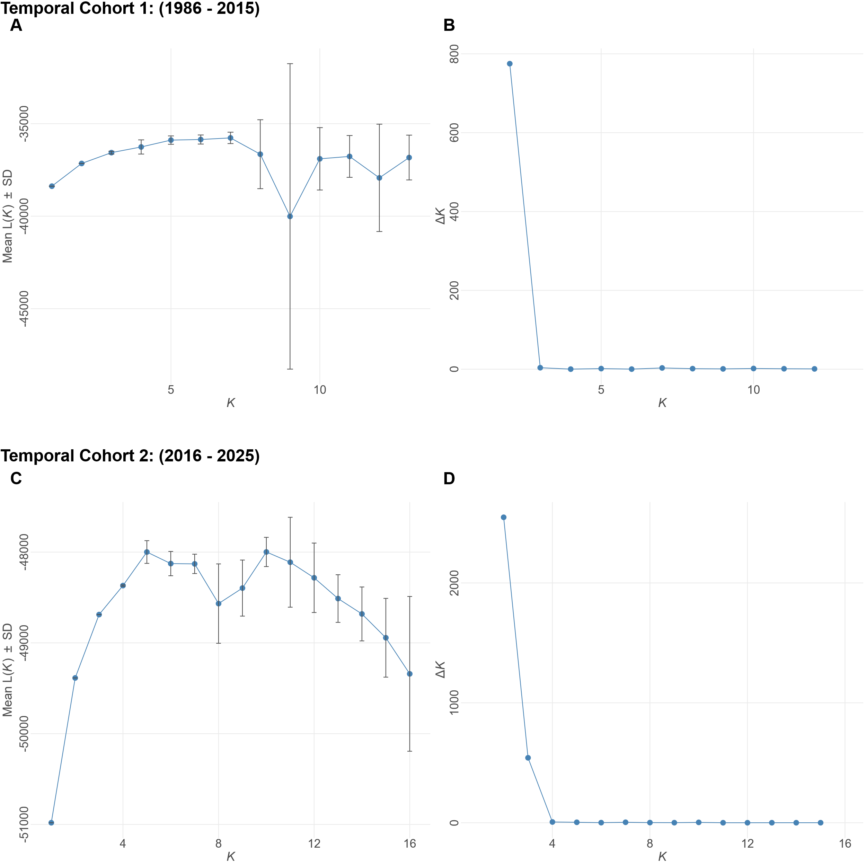
Supplementary Data SD18. STRUCTURE diagnostic plots for Wood Bison (B. b. athabascae) herd samples collected between 1986 – 2015 (top) and 2016 – 2025 (bottom). (A, C) Mean Log-likelihood (L(K)) over 10 replicates of K. (B, D) Delta K (ΔK) calculated following Evanno method (Evanno et al., 2005).

Herd | Wood Buffalo National Park
Herd | GR | HC | LB | NY | PAD | WENT | C1ª | C2^{b} | EINPW |  | ETH |  | HZ |  | MBS |  | NORD |  | RL |  | WAB |  | EINPP
GR |  | 0.007 | 0.020 | 0.019 | 0.005 | 0.047 | 0.013 | -0.011 | 0.073 |  | 0.084 |  | 0.086 |  | 0.040 |  | 0.088 |  | 0.109 |  | 0.203 |  | 0.116
HC | -0.012 |  | 0.020 | 0.021 | 0.007 | 0.035 | 0.013 | 0.004 | 0.048 |  | 0.065 |  | 0.064 |  | 0.032 |  | 0.073 |  | 0.099 |  | 0.202 |  | 0.129
LB | -0.011 | 0.000 |  | 0.031 | 0.020 | 0.055 | -0.006 | 0.015 | 0.069 |  | 0.090 |  | 0.085 |  | 0.033 |  | 0.082 |  | 0.132 |  | 0.216 |  | 0.139
NY | -0.001 | 0.002 | 0.006 |  | 0.024 | 0.053 | -0.013 | 0.018 | 0.057 |  | 0.070 |  | 0.061 |  | 0.053 |  | 0.076 |  | 0.108 |  | 0.223 |  | 0.165
PAD | -0.012 | -0.003 | -0.001 | 0.008 |  | 0.043 | 0.018 | -0.011 | 0.059 |  | 0.069 |  | 0.070 |  | 0.037 |  | 0.074 |  | 0.096 |  | 0.170 |  | 0.094
WENT | 0.003 | 0.002 | 0.003 | 0.006 | 0.011 |  | 0.042 | 0.020 | 0.077 |  | 0.113 |  | 0.092 |  | 0.090 |  | 0.099 |  | 0.112 |  | 0.247 |  | 0.158
C1ª | -0.007 | 0.001 | -0.016 | -0.017 | 0.002 | 0.006 |  | 0.012 | 0.053 |  | 0.068 |  | 0.062 |  | 0.038 |  | 0.067 |  | 0.108 |  | 0.210 |  | 0.150
C2^{b} | -0.019 | -0.003 | -0.001 | 0.006 | -0.014 | -0.004 | 0.001 |  | 0.056 |  | 0.067 |  | 0.065 |  | 0.037 |  | 0.070 |  | 0.092 |  | 0.177 |  | 0.104
EINPW | 0.035 | 0.027 | 0.029 | 0.029 | 0.036 | 0.032 | 0.026 | 0.035 |  |  | 0.040 |  | 0.027 |  | 0.077 |  | 0.049 |  | 0.132 |  | 0.250 |  | 0.195
ETH | 0.036 | 0.028 | 0.037 | 0.028 | 0.032 | 0.034 | 0.029 | 0.031 | 0.015 |  |  |  | 0.061 |  | 0.078 |  | 0.068 |  | 0.162 |  | 0.266 |  | 0.193
HZ | 0.039 | 0.038 | 0.040 | 0.034 | 0.046 | 0.028 | 0.034 | 0.041 | 0.014 |  | 0.030 |  |  |  | 0.088 |  | 0.058 |  | 0.143 |  | 0.244 |  | 0.197
MBS | 0.015 | 0.018 | 0.012 | 0.025 | 0.017 | 0.039 | 0.019 | 0.020 | 0.044 |  | 0.044 |  | 0.054 |  |  |  | 0.096 |  | 0.113 |  | 0.206 |  | 0.149
NORD | 0.032 | 0.023 | 0.031 | 0.021 | 0.031 | 0.035 | 0.021 | 0.031 | 0.016 |  | 0.024 |  | 0.021 |  | 0.053 |  |  |  | 0.171 |  | 0.259 |  | 0.201
RL | 0.057 | 0.054 | 0.068 | 0.063 | 0.054 | 0.041 | 0.062 | 0.052 | 0.080 |  | 0.089 |  | 0.081 |  | 0.065 |  | 0.092 |  |  |  | 0.228 |  | 0.180
WAB | 0.126 | 0.126 | 0.129 | 0.139 | 0.103 | 0.149 | 0.131 | 0.112 | 0.168 |  | 0.161 |  | 0.168 |  | 0.131 |  | 0.143 |  | 0.150 |  |  |  | 0.174
EINPP | 0.075 | 0.084 | 0.087 | 0.108 | 0.060 | 0.099 | 0.098 | 0.069 | 0.136 |  | 0.131 |  | 0.135 |  | 0.094 |  | 0.128 |  | 0.117 |  | 0.115
Supplementary Data SD19. F_{ST} significance estimates for temporal group 1 (1986 – 2015). Confidence intervals (CI) (95%) are based on 1000 bootstrap replicates. Lower CI bounds are reported below the diagonal, while upper CI bounds are reported above. Herd abbreviations are as described in Table 1, with the “WBNP” prefix excluded from WBNP subherds.

Supplementary Data SD20. F_{ST} significance estimates for temporal group 2 (2016 – 2025). Confidence intervals (95%) are based on 1000 bootstrap replicates. Lower CI bounds are reported below the diagonal, while upper CI bounds are reported above. Herd abbreviations are as described in Table 1, with the “WBNP” prefix excluded from WBNP subherds.
Herd | Wood Buffalo National Park
Herd | GR | HC | LB | NY | PAD | WENT | C1ª | C2^{b} | AISH | CL | EINPW | ETH | HZ | MBS | NAH | NORD | RL | WAB | EINPP
WBNPGR |  | 0.007 | 0.020 | 0.029 | 0.006 | 0.041 | 0.021 | -0.005 | 0.063 | 0.113 | 0.057 | 0.062 | 0.069 | 0.034 | 0.074 | 0.098 | 0.113 | 0.181 | 0.144
WBNPHC | 0.001 |  | 0.005 | 0.014 | 0.006 | 0.050 | 0.006 | 0.005 | 0.056 | 0.096 | 0.053 | 0.064 | 0.064 | 0.045 | 0.064 | 0.073 | 0.105 | 0.185 | 0.155
WBNPLB | 0.005 | -0.001 |  | 0.010 | 0.019 | 0.059 | -0.007 | 0.018 | 0.066 | 0.101 | 0.062 | 0.079 | 0.073 | 0.051 | 0.080 | 0.085 | 0.115 | 0.209 | 0.168
WBNPNY | 0.011 | 0.004 | -0.002 |  | 0.032 | 0.082 | -0.005 | 0.030 | 0.092 | 0.124 | 0.088 | 0.101 | 0.091 | 0.053 | 0.101 | 0.109 | 0.123 | 0.223 | 0.180
WBNPPAD | -0.002 | 0.000 | 0.006 | 0.013 |  | 0.047 | 0.023 | -0.006 | 0.056 | 0.101 | 0.048 | 0.067 | 0.067 | 0.047 | 0.057 | 0.077 | 0.108 | 0.167 | 0.129
WENT | -0.007 | 0.009 | 0.017 | 0.024 | 0.002 |  | 0.065 | 0.031 | 0.102 | 0.140 | 0.091 | 0.109 | 0.110 | 0.089 | 0.121 | 0.111 | 0.152 | 0.278 | 0.182
C1ª | 0.007 | 0.002 | -0.009 | -0.009 | 0.010 | 0.020 |  | 0.021 | 0.072 | 0.102 | 0.069 | 0.083 | 0.077 | 0.051 | 0.087 | 0.092 | 0.113 | 0.211 | 0.172
C2^{b} | -0.008 | 0.001 | 0.006 | 0.012 | -0.007 | -0.008 | 0.009 |  | 0.055 | 0.096 | 0.047 | 0.060 | 0.063 | 0.038 | 0.062 | 0.081 | 0.103 | 0.170 | 0.134
AISH | 0.036 | 0.033 | 0.033 | 0.052 | 0.034 | 0.033 | 0.041 | 0.033 |  | 0.069 | 0.023 | 0.048 | 0.043 | 0.085 | 0.073 | 0.060 | 0.154 | 0.262 | 0.229
CL | 0.066 | 0.060 | 0.062 | 0.067 | 0.064 | 0.068 | 0.062 | 0.061 | 0.036 |  | 0.073 | 0.096 | 0.089 | 0.130 | 0.148 | 0.114 | 0.185 | 0.318 | 0.270
EINPW | 0.022 | 0.027 | 0.023 | 0.040 | 0.025 | 0.022 | 0.030 | 0.023 | 0.007 | 0.039 |  | 0.043 | 0.035 | 0.085 | 0.064 | 0.060 | 0.160 | 0.259 | 0.211
ETH | 0.036 | 0.040 | 0.043 | 0.053 | 0.041 | 0.042 | 0.047 | 0.038 | 0.026 | 0.055 | 0.018 |  | 0.059 | 0.095 | 0.086 | 0.089 | 0.167 | 0.250 | 0.223
HZ | 0.041 | 0.041 | 0.039 | 0.056 | 0.042 | 0.048 | 0.045 | 0.041 | 0.018 | 0.044 | 0.012 | 0.031 |  | 0.110 | 0.100 | 0.093 | 0.170 | 0.264 | 0.226
MBS | 0.015 | 0.020 | 0.022 | 0.026 | 0.023 | 0.028 | 0.023 | 0.021 | 0.046 | 0.075 | 0.042 | 0.053 | 0.059 |  | 0.092 | 0.103 | 0.120 | 0.202 | 0.180
NAH | 0.030 | 0.023 | 0.032 | 0.039 | 0.021 | 0.034 | 0.035 | 0.025 | 0.038 | 0.075 | 0.023 | 0.037 | 0.045 | 0.045 |  | 0.100 | 0.173 | 0.249 | 0.173
NORD | 0.046 | 0.039 | 0.041 | 0.058 | 0.043 | 0.053 | 0.046 | 0.043 | 0.028 | 0.059 | 0.022 | 0.045 | 0.046 | 0.061 | 0.042 |  | 0.176 | 0.252 | 0.248
RL | 0.065 | 0.065 | 0.069 | 0.076 | 0.059 | 0.066 | 0.071 | 0.060 | 0.089 | 0.112 | 0.093 | 0.094 | 0.096 | 0.065 | 0.090 | 0.109 |  | 0.249 | 0.205
WAB | 0.129 | 0.131 | 0.145 | 0.154 | 0.119 | 0.177 | 0.147 | 0.123 | 0.188 | 0.227 | 0.185 | 0.174 | 0.168 | 0.136 | 0.151 | 0.181 | 0.163 |  | 0.186
EINPP | 0.090 | 0.099 | 0.113 | 0.118 | 0.083 | 0.107 | 0.116 | 0.087 | 0.161 | 0.188 | 0.141 | 0.150 | 0.151 | 0.116 | 0.110 | 0.162 | 0.133 | 0.124

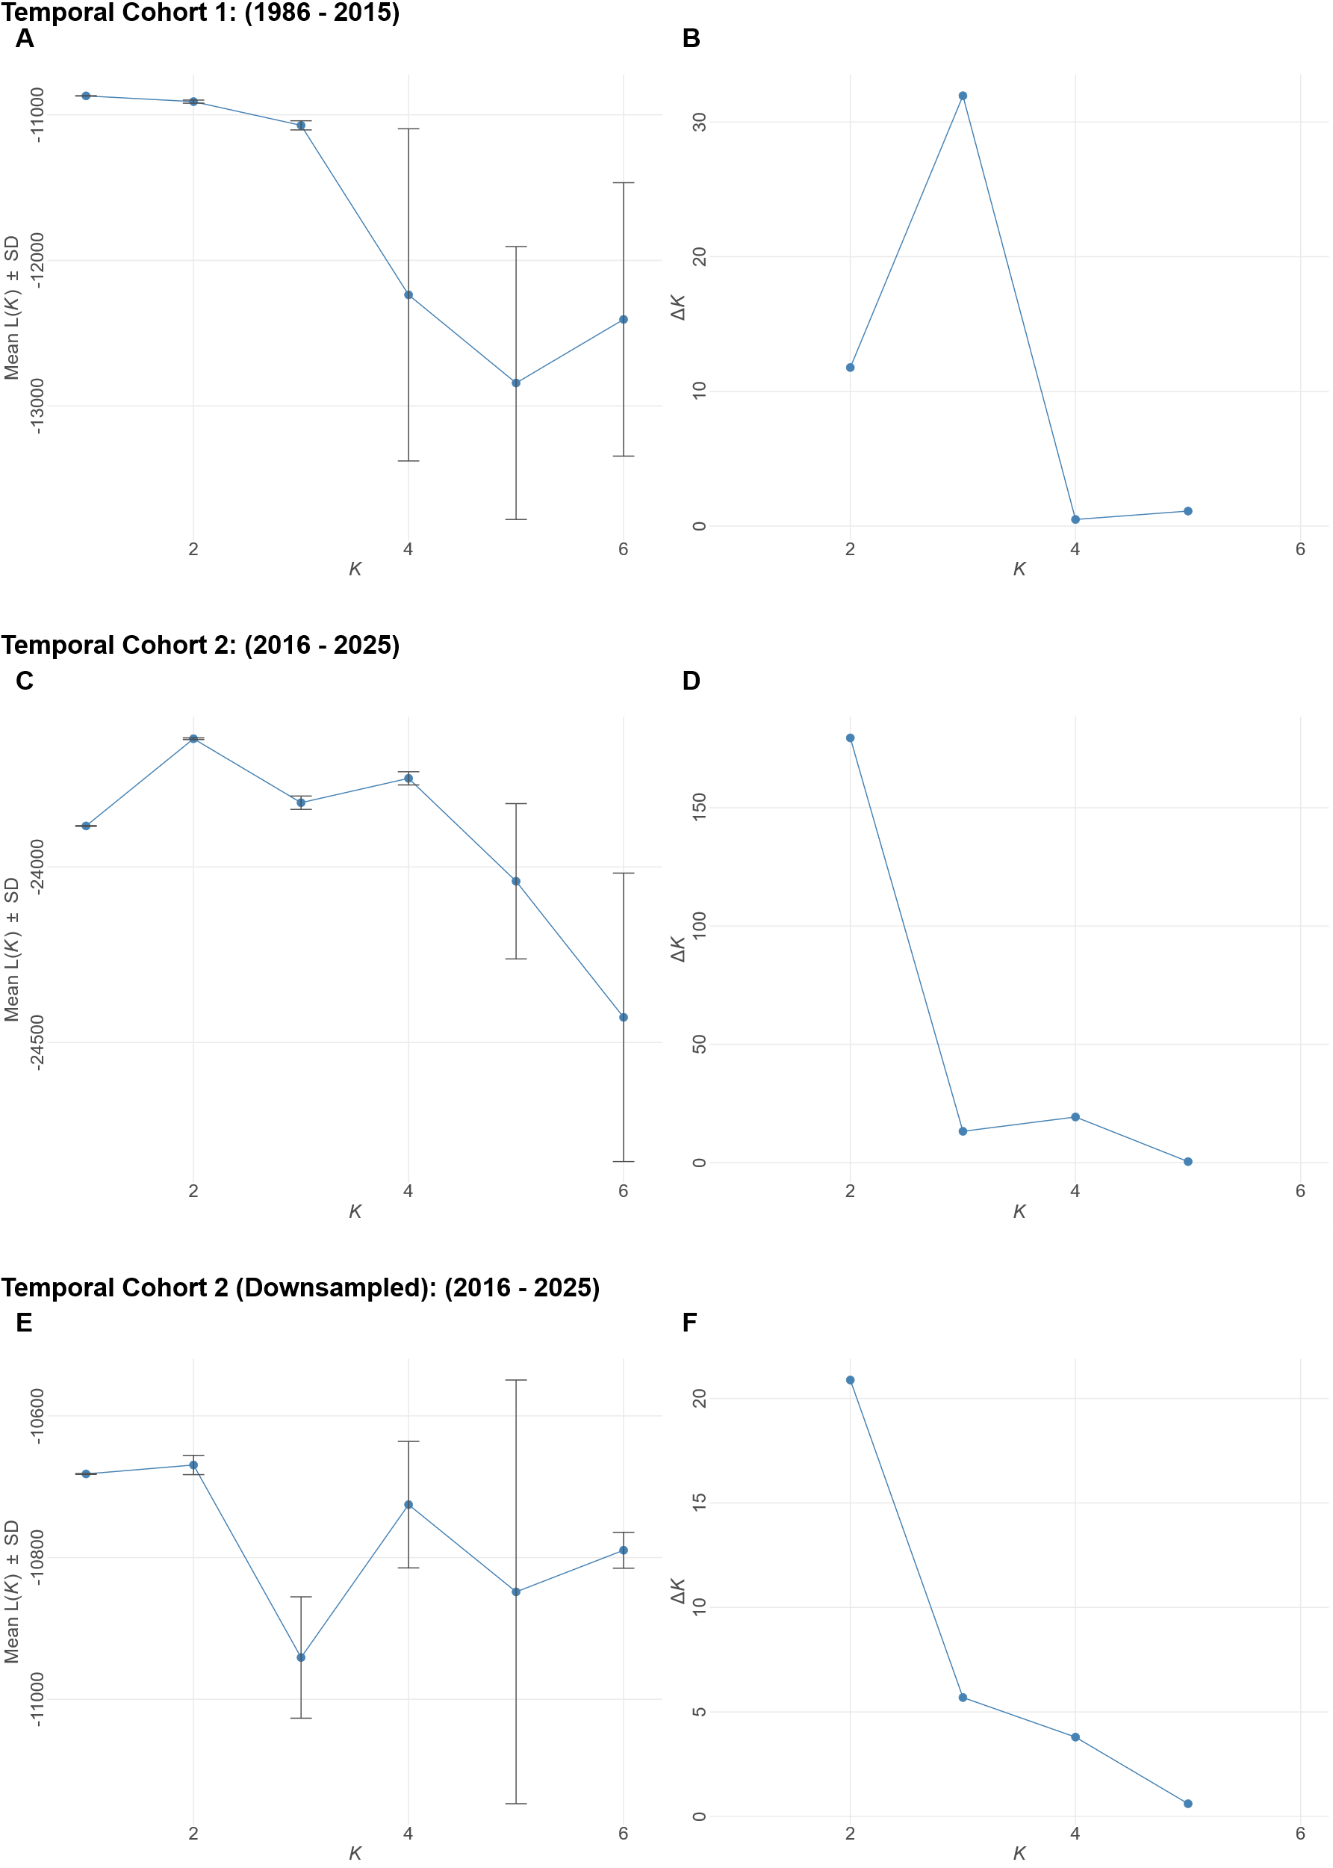
Supplementary Data SD21. STRUCTURE diagnostic plots for Wood Bison (B. b. athabascae) in Wood Buffalo National Park samples collected 1986 – 2015 (top) and 2016 – 2025 (middle, bottom). (A, C, E) Mean Log-likelihood (L(K)) over 10 replicates of K = 1 to K = 6. (B, D, F) Delta K (ΔK) calculated following Evanno method (Evanno et al., 2005). Both top and middle diagnostic plots are determined using all samples available within each respective temporal cohort, whereas the bottom plot represents the down-sampled WBNP 2016 – 2025 dataset.
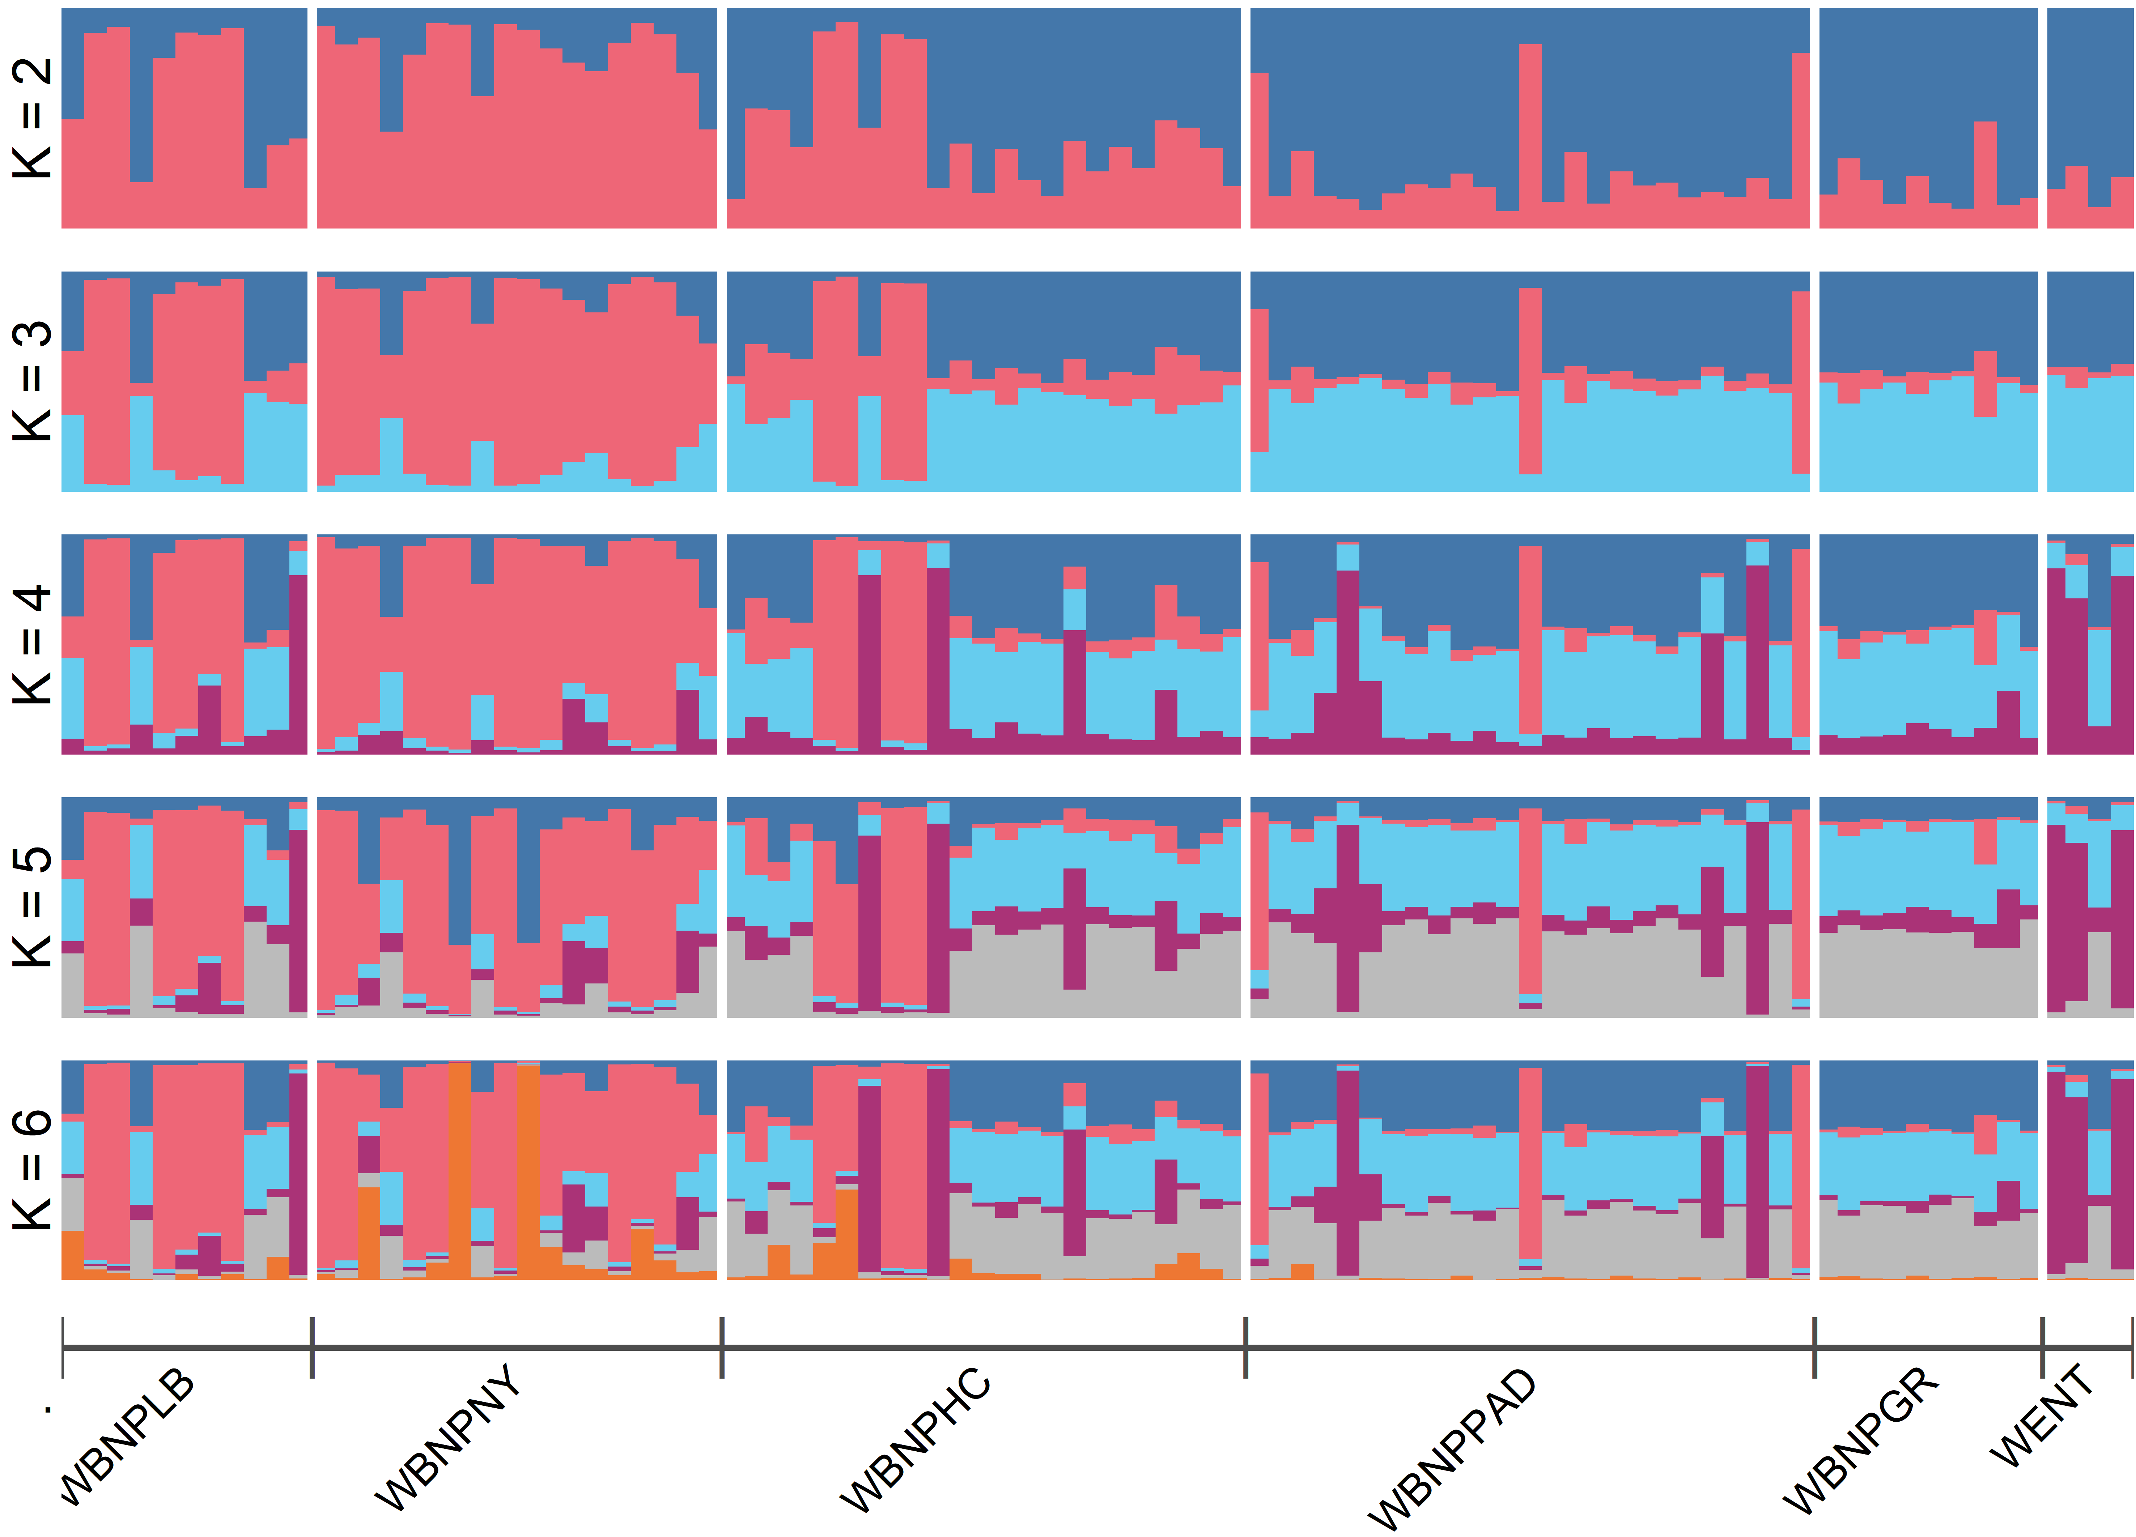
Supplementary Data SD22. STRUCTURE Bayesian clustering results for T2 (2016 – 2025) WBNP wood bison (B. b. athabascae) samples. K = 2 through K = 6 depicted for T2 randomly down sampled to match subherd sample sizes in T1 (1986 – 2015).

Supplementary Data SD23. Mean cluster assignment coefficients (Q) between purported genetic clusters within Wood Buffalo National Park (WBNP). Posterior probability of assignment for sampled individuals within each identified herd at inferred K = 2 clusters, representing assignment between both putative genetic clusters, using Bayesian clustering approach as implemented by STRUCTURE. T1 = temporal group 1 (1986 – 2015) and T2 = temporal group 2 (2016 – 2025). Herd abbreviations are as described in Table 1. C1 and C2 represent purported genetic clusters. Mean values for each population are reported with the standard deviation.
Herd | Q_{C1} | Q_{C2}
GR | 0.183 ± 0.189 | 0.817 ± 0.189
HC | 0.417 ± 0.343 | 0.583 ± 0.343
LB | 0.668 ± 0.363 | 0.332 ± 0.363
NY | 0.836 ± 0.191 | 0.164 ± 0.191
PAD | 0.191 ± 0.194 | 0.809 ± 0.194
WENT | 0.169 ± 0.130 | 0.831 ± 0.130

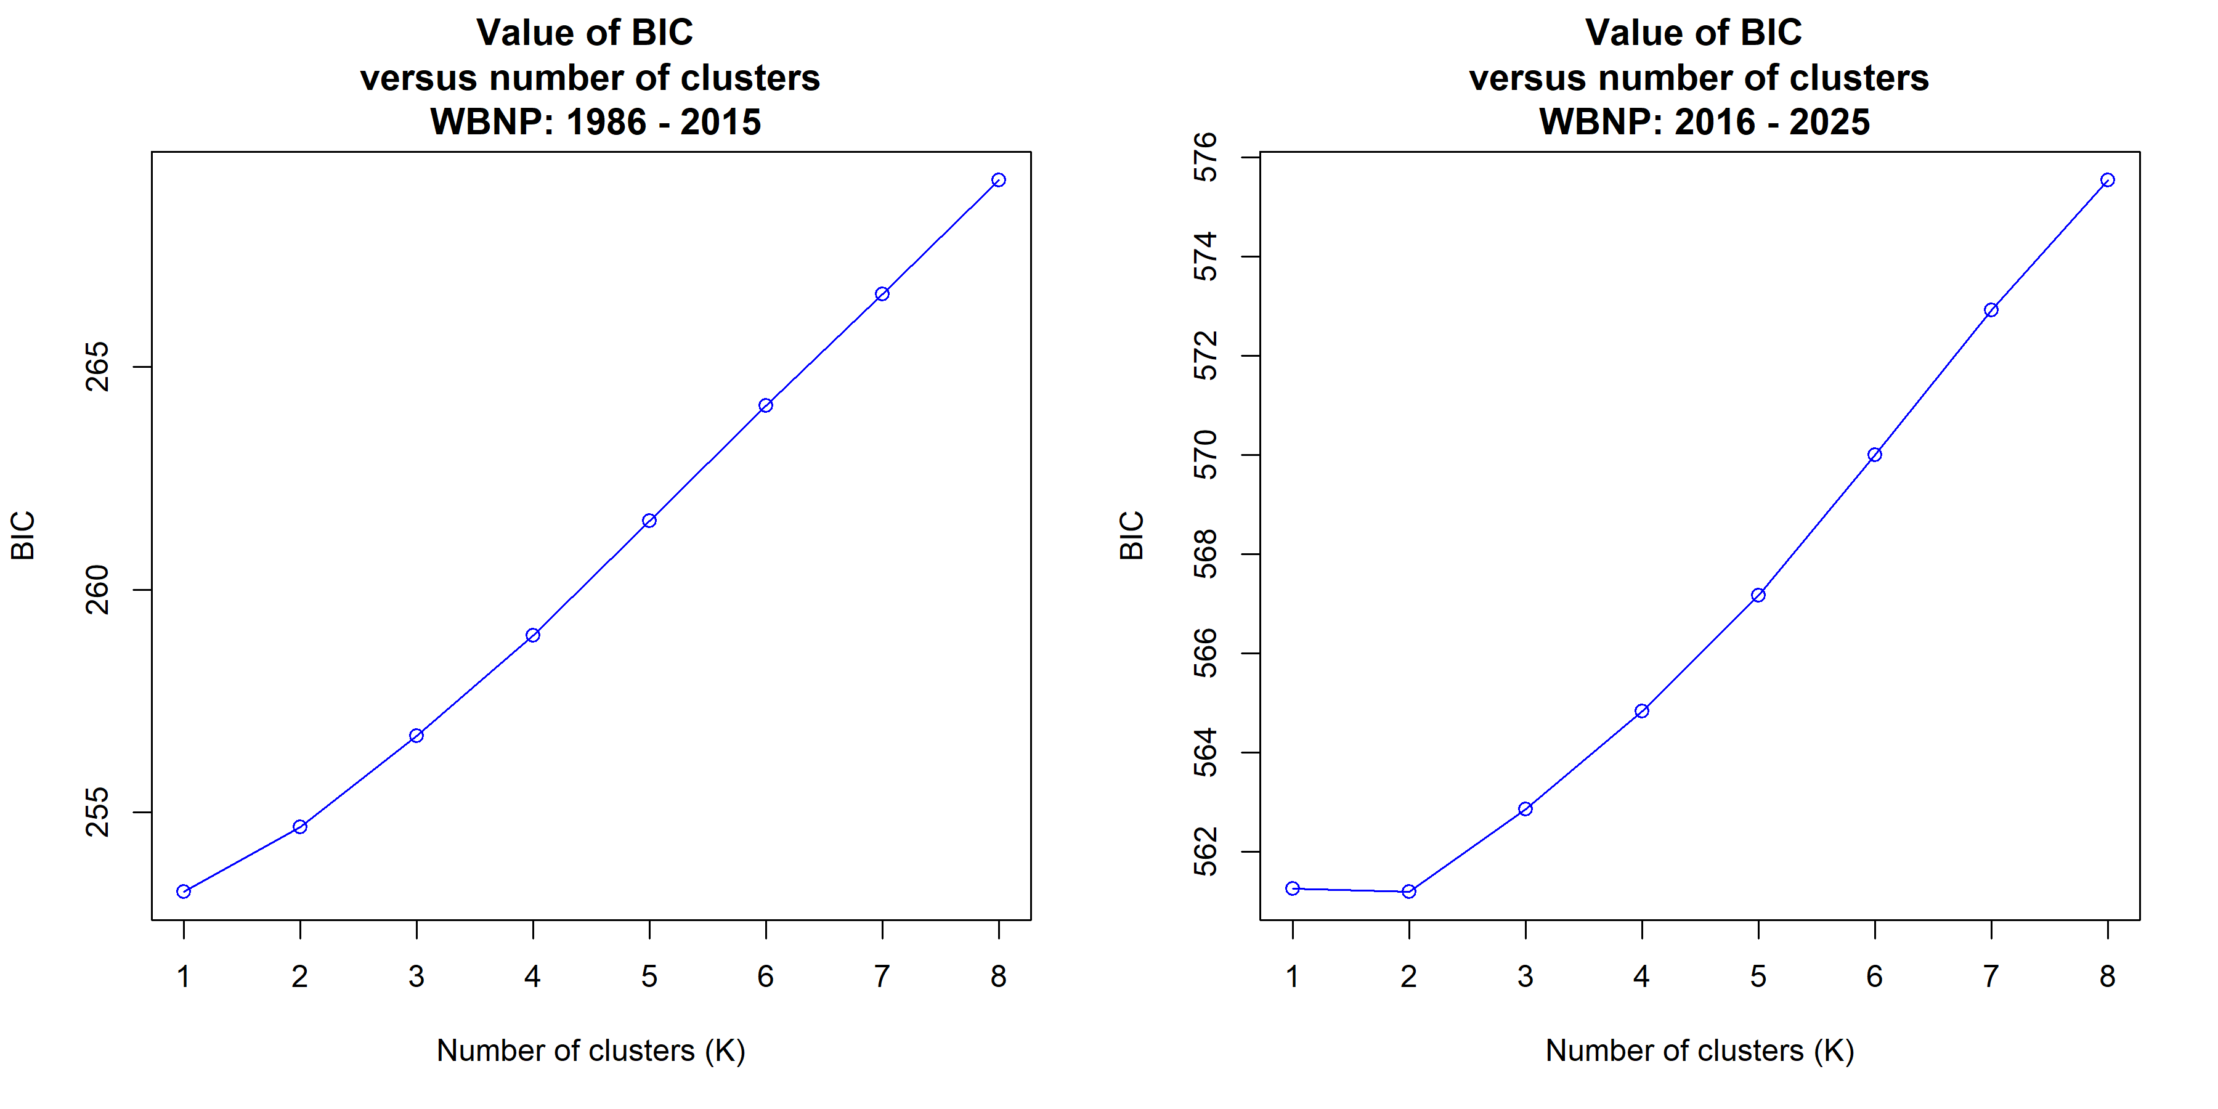
Supplementary Data SD24. Evaluation of clustering intensity. Unsupervised K-means clustering for the Wood Buffalo National Park (WBNP) subpopulations collected (left) T1: 1986 – 2015, and (right) T2: 2016 – 2025. Bayesian Information Criterion (BIC) values are plotted against the number of clusters (K) in both cohorts. In T1, the minimum BIC is observed at K = 1, indicating a single genetic cluster with no discernable substructure, whereas in T2, the minimum BIC is observed at K = 2 indicating the emergence of two subgroups.

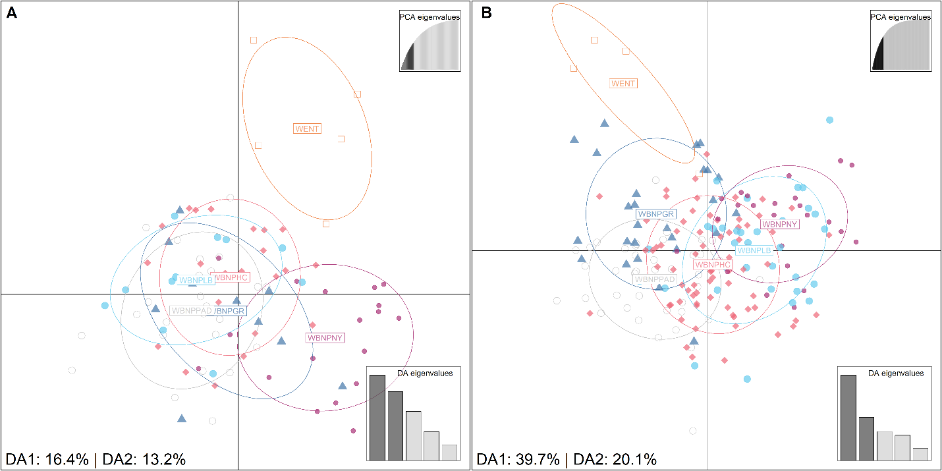
Supplementary Data SD25. Genetic substructure of Wood Buffalo National Park (WBNP) within temporal cohorts. Discriminant analysis of principal components (DAPC) based on 47 microsatellite loci for (A) samples collected 1986 – 2015, with 50 principal components (PCs) retained, and (B) samples collected 2016 – 2025, with 30 PCs retained. Ellipses represent one standard deviation around the centroid for each cluster, and percentage values indicate proportion of genetic variance explained by discriminant axes. Herd abbreviations are as described in Table 1.

Supplementary Data SD26. Temporal Comparison of Genetic Diversity Indices. H_{E}: expected heterozygosity; H_{O}: observed heterozygosity; A_{R}: allelic richness. V represents the test statistic from a Wilcoxon signed-rank test, calculated as the sum of positive ranks for differences between time periods (T1 and T2). Statistically significant results (p < 0.05) are indicated in bold. "n/a" denotes cases where insufficient data prevented the calculation of allelic richness for both time periods. Herd abbreviations are as described in Table 1.
 | H_{E} |  | H_{O} |  | A_{R}
Herd | V | p | V | p | V | p
EINPW | 547.5 | 0.866 | 476.5 | 0.357 | 543 | 0.830
ETH | 485 | 0.890 | 533.5 | 0.861 | 424 | 0.294
HZ | 689.5 | 0.105 | 619.5 | 0.148 | 810 | 0.009
MBS | 673 | 0.251 | 574.5 | 0.916 | 691 | 0.182
NORD | 564 | 0.604 | 505 | 0.892 | 597 | 0.373
RL | 589 | 0.600 | 542.5 | 0.824 | 676 | 0.240
WAB | 602.5 | 0.502 | 516.5 | 0.797 | 575 | 0.710
WBNPGR | 576 | 0.903 | 587.5 | 0.808 | 515 | 0.611
WBNPHC | 673 | 0.251 | 619.5 | 0.561 | 715 | 0.112
WBNPLB | 611 | 0.623 | 472 | 0.333 | 461 | 0.281
WBNPNY | 652 | 0.354 | 546 | 0.752 | 654 | 0.347
WBNPPAD | 600.5 | 0.703 | 729 | 0.082 | 579 | 0.879
WENT | 527.5 | 0.514 | 477 | 0.838 | n/a | n/a
WBNPC1 | 686.5 | 0.197 | 531.5 | 0.735 | 642 | 0.416
WBNPC2 | 601 | 0.699 | 593 | 0.397 | 543 | 0.830
EINPP | 613.5 | 0.428 | 572 | 0.937 | 685 | 0.204

Supplementary Data SD27. F_{IS} significance estimates for both temporal groups. Confidence intervals (95%) are based on 1000 bootstrap replicates. Herd abbreviations are as described in Table 1.
Temporal Cohort | Herd | Lower Limit | Upper Limit
T1 | EINPP | -0.0077 | 0.0315
T1 | WAB | -0.0723 | 0.0796
T1 | WENT | -0.0423 | 0.1628
T1 | NORD | -0.0718 | 0.0646
T1 | RL | -0.0527 | 0.0598
T1 | HZ | -0.0472 | 0.0298
T1 | WBNPGR | -0.0519 | 0.0417
T1 | EINPW | -0.0038 | 0.0363
T1 | ETH | -0.0621 | 0.0336
T1 | WBNPPAD | -0.0298 | 0.0376
T1 | MBS | -0.012 | 0.0214
T1 | WBNPLB | -0.0291 | 0.0935
T1 | WBNPNY | -0.0495 | 0.033
T1 | WBNPHC | 0.0022 | 0.0763
T1 | WBNPC2 | -0.0145 | 0.0406
T1 | WBNPC1 | -0.0173 | 0.0497
T2 | EINPP | -0.0337 | 0.0432
T2 | NAH | -0.0317 | 0.1317
T2 | WAB | -0.1263 | 0.0266
T2 | WENT | -0.1514 | 0.0983
T2 | NORD | -0.054 | 0.0522
T2 | RL | -0.07 | 0.0062
T2 | HZ | -0.034 | 0.0673
T2 | WBNPGR | -0.0095 | 0.0558
T2 | EINPW | -0.0598 | 0.0389
T2 | ETH | -0.046 | 0.0217
T2 | WBNPPAD | 0.0103 | 0.063
T2 | MBS | -0.0378 | 0.0472
T2 | WBNPLB | -0.0415 | 0.0225
T2 | WBNPNY | -0.0581 | 0.0395
T2 | AISH | -0.0269 | 0.03
T2 | WBNPHC | 0.0094 | 0.0558
T2 | CL | -0.08 | -0.0041
T2 | WBNPC2 | 0.0095 | 0.0558
T2 | WBNPC1 | -0.0382 | 0.0223

Supplementary Data SD28. Comparative analysis of expected heterozygosity within temporal groups. Observed differences (ΔH_{E}) represent the deficit or surplus of heterozygosity for each target herd relative to the pooled remainder of its respective temporal group. Statistical significance determined using 999 permutations, with the Benjamini-Hochberg adjusted p-value indicating the probability of the observed difference occurring by chance. Significant observations are denoted in bold. Herd abbreviations are as described in Table 1.
Temporal Cohort | Population | Obs ΔH_{E} | p
T1 | WBNPPAD | 0.013 | 0.834
T1 | WBNPC2 | 0.011 | 0.644
T1 | WBNPHC | -0.008 | 0.125
T1 | MBS | -0.019 | 0.008
T1 | WBNPC1 | -0.021 | 0.021
T1 | WBNPGR | -0.025 | 0.019
T1 | WBNPNY | -0.035 | 0.009
T1 | WBNPLB | -0.041 | 0.004
T1 | EINPW | -0.070 | 0.003
T1 | HZ | -0.072 | 0.003
T1 | RL | -0.078 | 0.003
T1 | WENT | -0.092 | 0.008
T1 | ETH | -0.097 | 0.003
T1 | WAB | -0.102 | 0.003
T1 | NORD | -0.119 | 0.003
T2 | WBNPPAD | 0.021 | 0.090
T2 | WBNPC2 | 0.019 | 0.018
T2 | WBNPGR | 0.000 | 0.345
T2 | WBNPHC | -0.003 | 0.412
T2 | WBNPLB | -0.017 | 0.018
T2 | WBNPC1 | -0.017 | 0.014
T2 | WBNPNY | -0.033 | 0.002
T2 | MBS | -0.036 | 0.002
T2 | EINPW | -0.070 | 0.002
T2 | NAH | -0.073 | 0.002
T2 | ETH | -0.076 | 0.002
T2 | RL | -0.077 | 0.002
T2 | AISH | -0.085 | 0.002
T2 | HZ | -0.087 | 0.002
T2 | NORD | -0.093 | 0.002
T2 | WENT | -0.112 | 0.003
T2 | WAB | -0.124 | 0.002
T2 | CL | -0.150 | 0.002

